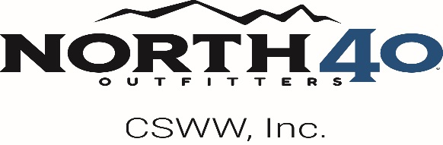

House of Fly - Content and E-Commerce Production Assistant
- 5109 Alaska Trail, Great Falls, MT 59405, USA
- Full-time
- Location: Great Falls Corporate Office

Company Description
To tell the story of North 40 Outfitters is to tell a success story of the people of the Northwest. We do what we love, and love what we do because we’re passionate. We’re dedicated. We give it all we’ve got and then we get up in the morning and do it all over again. We’re farmers and ranchers. We’re barrel racers and river chasers. We’re honest. We’re helpful. And our families, our friends, and our communities are everything. This is us. This is who we are. It’s what we do every day.
Our Values:
- Embrace Authenticity
- Encourage Transparency
- Promote Learning
- Build Trust
- Earn Respect
- Deliver Value
- Serve Our Customers

Job Description
House of Fly is looking to hire an E-Commerce & Content Production Assistant to join our team.
We believe that each team member plays a vital role in the success of our company. We are looking for authentic, enthusiastic people who love fly fishing, the outdoors, and the culture that surrounds it. As an E-Commerce & Content Production Assistant, you will play an important role in helping bring our gear and stories to life online—making sure our products are presented clearly, accurately, and in a way that reflects who we are.
To succeed in this role, you should be organized, detail-oriented, and comfortable learning new systems and creative tools. Just as important, you should have a genuine interest in fly fishing and the gear, brands, and experiences that make the sport unique.

Qualifications
- Passion for fly fishing and a genuine interest in gear, brands, and industry culture
- Upload and manage products on the House of Fly website, including images, descriptions, variants, and metadata
- Write and edit clear, accurate, and engaging product descriptions that reflect real-world use and brand voice
- Help ensure new products are ready to launch by confirming details, images, and supporting materials are complete
- Assist with updates to blogs, fishing reports, event pages, and other website content
- Upload, organize, and maintain a clean and searchable asset library
- Assist with light photo editing and exports (training provided)
- Work closely with the creative and marketing teams to support projects and maintain brand consistency
- Assist with studio product photography for gear, apparel, and accessories
- Assist with lifestyle photography in outdoor and fly fishing environments
- Support basic editing for social media, product features, and storytelling content
- Strong attention to detail and organizational skills
- Comfortable working on a computer and learning new systems
- Ability to write and edit clear, accurate copy
- Willingness to learn new tools, workflows, and creative skills
- Ability to take direction and work independently or as part of a team
- Experience using a camera (photo or video) preferred
- Familiarity with Adobe Creative Suite (Lightroom, Photoshop, Premiere Pro) preferred
- Experience with e-commerce platforms (Adobe Commerce or similar) preferred
- Basic HTML knowledge and understanding of SEO-friendly product listings preferred
- Drone operating and/or editing experience is a plus

Additional Information
BENEFITS & COMPENSATION
We offer a competitive wage and a rewarding, creative, and supportive work environment immersed in fly fishing culture. Team members have opportunities to grow their creative and technical skills and may occasionally travel for on-location shoots, product campaigns, and industry events.
We also provide generous benefits and perks, including paid holidays, a 401(k) option, Health Savings Accounts (HSAs), medical, dental, vision, and life insurance, along with a phenomenal employee discount on all products sold by North 40 Outfitters.
North 40 Outfitters is proud to be an Equal Opportunity Employer.

